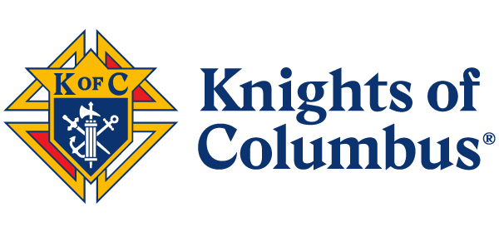
Join us at
The Stratford Centennial Celebration for the
Knights of Columbus First Annual Car Show
Sunday, September 28th, 2025 11am– 4pm
Registration: $20.00 Donation
ALL PROCEEDS BENEFIT KNIGHTS OF COLUMBUS CHARITIES
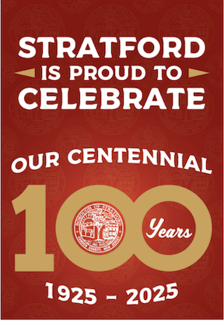
Holy Family Council #7800

Location: Cars will park along Vassar Ave between East Atlantic Ave and Warwick Road, Stratford, NJ 08084


Complimentary Dash Plaque for all pre-registered cars. Join the festivities for 50/50 Drawing, Prizes, Entertainment, and Concessions.
Trophies to be awarded for People’s Choice, Best in Show 1st, 2^{nd,} and 3rd Place Mayor’s Pick, Grand Knight’s Award, and Town Council’s choice.
You must arrive and register BY 9:30 AM for judging, and must stay the entire event. Awards at 3:30 p.m.

-----------------------------------------------------------------------------------------------------------------------NOTICE: The participant's vehicle must be insured by the participant. Knights of Columbus Holy Family Council 7800, Stratford Boro, and any Sponsor, volunteers, or representatives shall NOT be held responsible for any loss or damage to the participant’s vehicle, persons, or property. Participants shall follow all event rules as directed. The Car Show Committee Chairman will have the final authority concerning any event decisions. Participants must be 18 years of age or older. My signature below indicates my acceptance.

Signature_____________________________________________________________________
Name:________________________________________________________________________
Phone:___________________________________Email:______________________________
Car Make:_____________________Model:_______________________Year:_____________
For additional information, contact: KofC 7800 Mark (856) 472-9649. Please make checks payable to Knights of Columbus Holy Family Council #7800. Please email registrations to: CarShow2025@kofc7800.org
See also https://www.kofc7800.org for online registration & payment option and final meet-up times.
U.S. Mail payments and completed forms to P.O. Box 221, Stratford, NJ 08084.

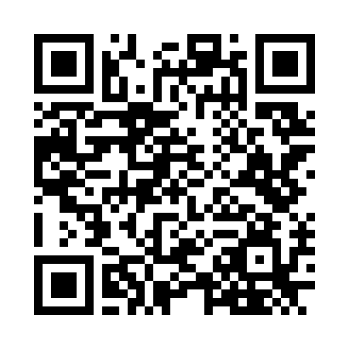Download Form

